**NAME:**

**PROBLEM 1:** Beam AB is supporting a triangularly distributed load of maximum intensity qo acting on the right-hand half of the beam. For this loading condition Ax=-qoL/24 and Bx=-5qoL/24.

C:\Documents and Settings\bucinelr\My Documents\Courses\MER311 Spring 10\ExamSolutions\GT4th9_4_10.tif

y

x

**1a.**  Derive equations that express how V, M, θ, and u change as a function of the distance along the length of the beam.

**1b.** Using the graph paper on the next page draw the V, M, θ, and u diagrams for this beam. For the following values calculate the magnitude, illustrate the location, and show the distance from the origin on the coordinate system.

1. Maximum and minimum values of the shear force.
2. Maximum and minimum values of the bending moment.
3. Maximum and minimum values of the curvature.
4. Maximum value of the deflection.
5. All intercepts and points of inflection on all of the diagrams.

C:\Documents and Settings\bucinelr\My Documents\Courses\MER311 Spring 10\ExamSolutions\GT4th9_4_10.tif

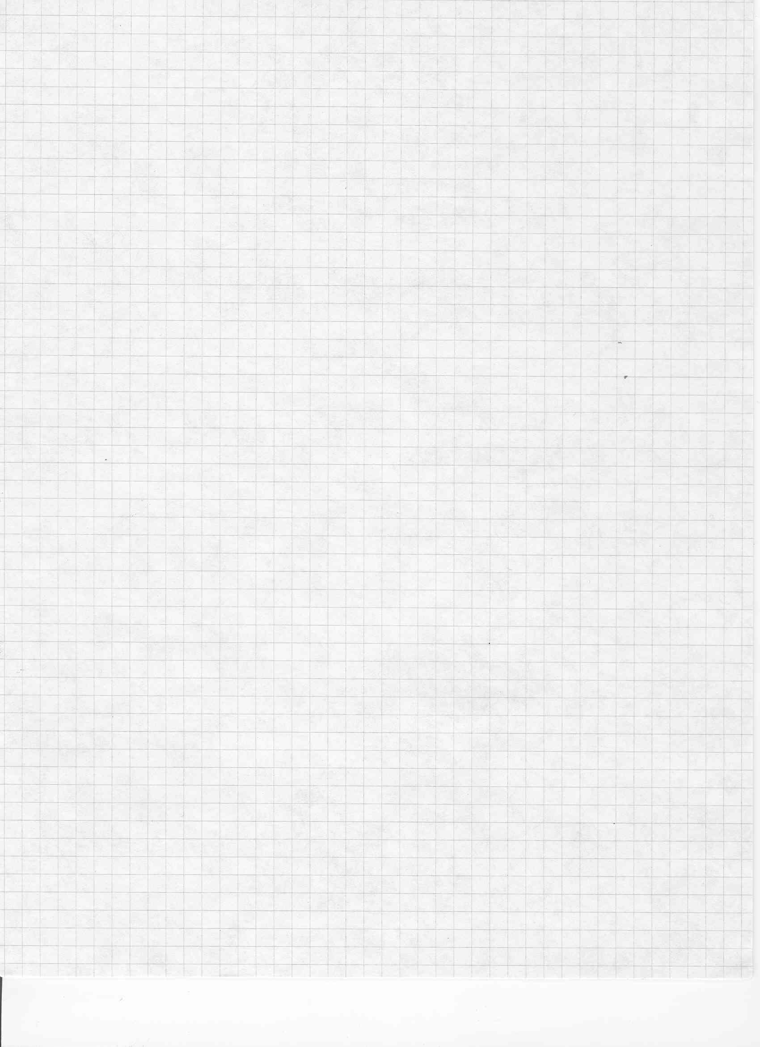

**PROBLEM 2:** For the structure being shown, θ=30° and E=29x106 psi.

**2a.** Using Euler’s formula determine the largest load P which may be applied to the structure when only buckling in the plane of the structure is considered.

**C:\Documents and Settings\bucinelr\My Documents\Courses\MER311 Spring 10\ExamSolutions\BJ2nd11_154bc.TIFC:\Documents and Settings\bucinelr\My Documents\Courses\MER311 Spring 10\ExamSolutions\BJ2nd11_154ab.TIFC:\Documents and Settings\bucinelr\My Documents\Courses\MER311 Spring 10\ExamSolutions\BJ2nd11_154abc.TIFC:\Documents and Settings\bucinelr\My Documents\Courses\MER311 Spring 10\ExamSolutions\BJ2nd11_154.tif**

**2b.** Knowing that a factor of safety of 2.8 is required, what is the largest load P which can be applied to the structure.